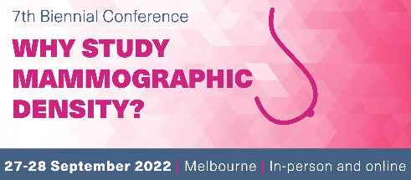
WHY STUDY MD 2022 CONSUMER SCHOLARSHIP APPLICATION

Email to WhyStudyMD-gohad@uwa.edu.au

Your name:

Your occupation:

Are you collaborating (or have you previously collaborated) as a consumer representative/community member with an existing organisation or group of researchers? (Yes/No)

If Yes, can you please describe which organisation/groups you have collaborated with.

Can you explain your interest in mammographic density research and in attending the Why Study Mammographic Density? Conference?

Are you hoping to attend the entire conference or just part (please use an x)
- entire conference
- Day 1 only
- Day 2 only

Are you planning to attend online or in person? (Yes/No)

Please describe how this scholarship would assist you in your role as a consumer representative/community member (few lines/paragraph):

Would the scholarship enable you to attend or are there still additional barriers for allowing you to attend either online or in person. Please describe.

